|  |  |  |  |  |  |  |  |  |
| --- | --- | --- | --- | --- | --- | --- | --- | --- |
| ASSIGNMENT-2       |  |  | | --- | --- | | Assignment Date | 29 September 2022 | | Student Name | B. Surya | | Student Roll Number | 420619104037 | | Maximum Marks | 2 Marks |     Question : Upload The Data Set To Cognos Analytics, Prepare The Data ,Explore And Create Interactive Dashboard.  Task 1: Sales By Customer.  Task 2: Sales By Location.  Task 3: Sales By Sales Representative.  Task 4: Received Inventory From Supplier  Task 5: Inventory Stock for Warehouse Locations  Task 6: Sales Trend  Task 7:Monthly Sales  Task 8: Actual and Received Inventory by Month |

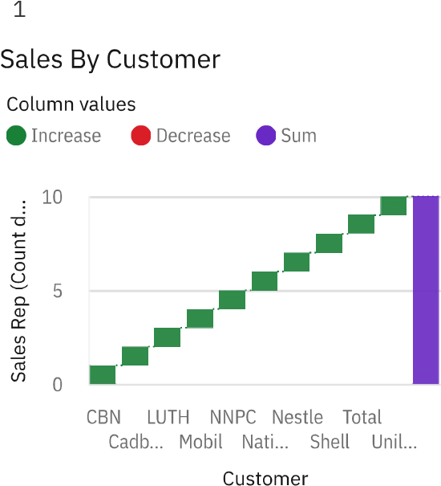



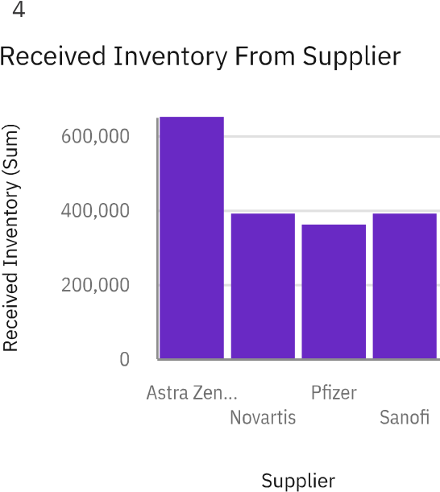

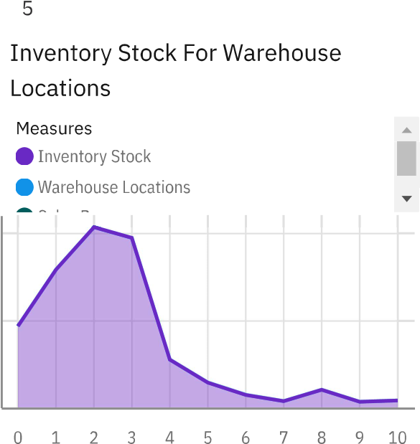

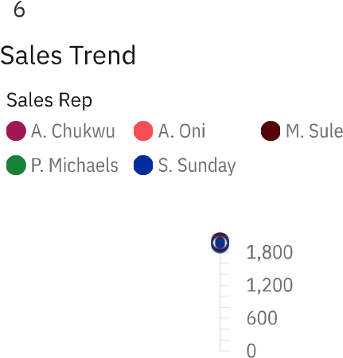

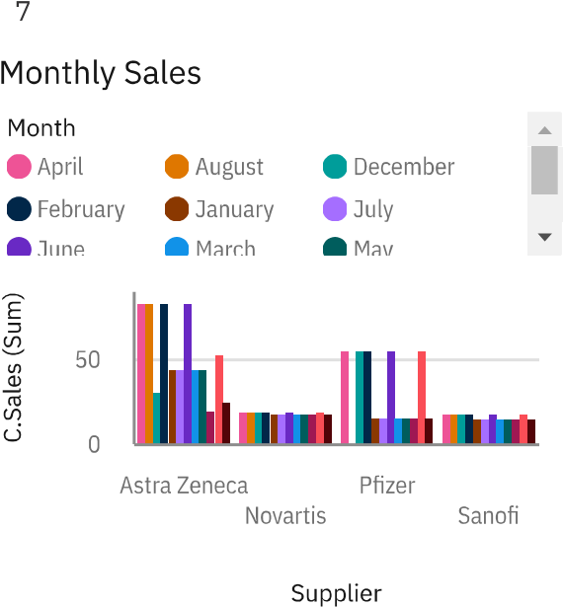

|  |  |
| --- | --- |
| April | 150,000 |
| August | 120,000 |
| December | 120,000 |
| February | 135,000 |
| January | 220,000 |
| July | 145,000 |

Tab 8

Actual and Received Inventory By Month

|  |
| --- |
| Received Invent…. |